LOCAL AREA CHILD PROTECTION INDICATORS:
QUARTERLY / SIX MONTHLY REPORT (AUGUST TO OCTOBER 2021)

INTRODUCTION
This report sets out the Data Sub-Group’s key findings from its analysis of the Minimum Dataset for Child Protection Committees indicators. The report’s analysis is organised under the following headings:
- Key findings from the data.
- Additional data work – updates and proposed data work.

The data, charts, tables and (optional) scrutiny questions are contained in the Appendix to this report. Where appropriate and available, the Data Sub-Group has also brought wider data and intelligence (e.g. other local indicators, audit and self-evaluation exercises, and insights from local managers and staff) into its analysis of the Minimum Dataset indicators.

KEY FINDINGS FROM THE DATA
In this section, the Data Sub-Group is encouraged to review all the data in the Appendix, consider the scrutiny questions and identify the headline messages to highlight to the Committee.
- Guard against providing written commentary on every indicator. Instead focus on the most important data findings (i.e. akin to ‘exception reporting’). For example, a notable trend or spike in an indicator’s data in the last 1-2 quarters. It may be helpful to copy over a chart or table from the Appendix into this report to help highlight the data change.
- Where referring to a notable trend or spike, try to explain the trend or spike – noting this may require additional data and intelligence not contained in the Minimum Dataset. The (optional) scrutiny questions may support you to consider the factors that might contribute to the data trend or spike.

Where notable changes are identified and cannot be immediately explained, consider what might be the ask of the Child Protection Committee. For example, ask for decision or approval to:
- Undertake further, more detailed analysis of the statistical data and other (e.g. audit) activity.
- Respond to specific scrutiny questions.
- Take action in the form of increased monitoring, initiate new training programme, etc.

ADDITIONAL DATA WORK
In this section, the Data Sub-Group is encouraged to provide an update on other wider child protection data activity that has been completed, is in progress, or is planned. Such data work might include:
- Analysis of other, locally important data indicators.
- Qualitative data work – e.g. surveys or experiential data from children and families.
- Self-evaluation and audit work – e.g. observations of Child Protection Planning Meetings or audits of Child’s Plans.

By including the key messages from wider data work here, this report and Appendix in effect becomes the single data paper that the Committee receives.

PLEASE NOTE, THIS REPORT COULD EXTEND TO 2 PAGES.
DATA APPENDIX
EARLY STAGE CHILD PROTECTION ACTIVITY

Indicators 1, 2A and 2B: Number of Police Scotland-recorded Child Protection Concern Reports and Inter-Agency Referral Discussions
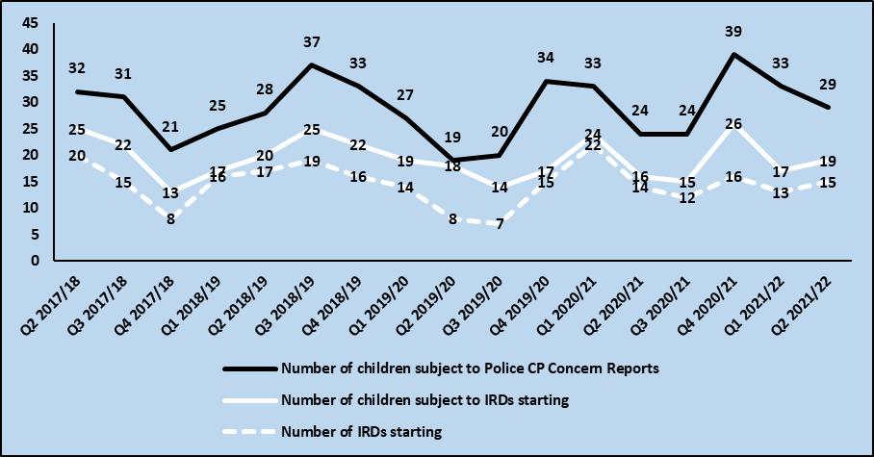

Scrutiny questions to support analysis of the data:
- How many child protection concerns have been received from health, education and other sources?
- Have all core agencies (health, police and social work) attended the initial IRD meeting?
- (If social work provide IRD data) How many children have been subject to two or more IRDs in the last 12 months?
- If Child Protection Investigations is a distinct local process, how many children were subject to Investigation in the quarter?

Indicators 3 & 4: Number of Children subject to Joint Investigative Interview and Child Protection Medical Examination
 | Aug-Oct | Nov-Jan | Feb-Apr | May-Jul | Aug-Oct | Nov-Jan | Feb-Apr | May-Jul
 | Q1 20/21 | Q2 20/21 | Q3 20/21 | Q4 20/21 | Q1 21/22 | Q2 21/22 | Q3 21/22 | Q4 21/22
Number of children subject to a Joint Investigative Interview
Number of children subject to a Child Protection Medical Examination | Not available until later in 2022 once NHS CELLMA IT system goes live

Scrutiny questions to support analysis of the data:
- How many and/or % of the JIIs used the Scottish Child Interview Model?
- What was the breakdown by Child Protection Medical Examination type?
- What were the outcomes of the Child Protection Medical Examination (i.e. what harm or abuse was identified)?

CHILD PROTECTION PLANNING MEETINGS

Indicators 5A & 5B: Number of Children subject to Initial and Pre-Birth Child Protection Planning Meetings
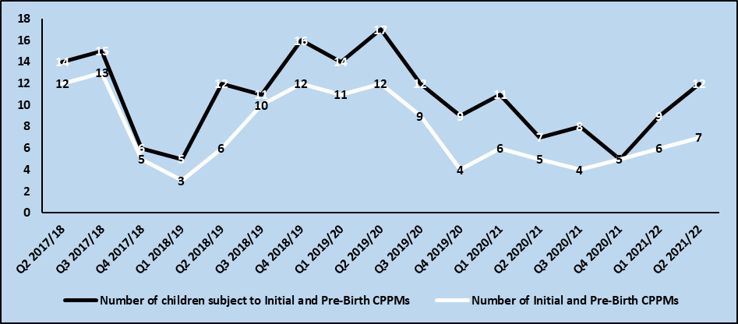

Scrutiny questions to support analysis of the data:
- Were there large family groups of (e.g. 3 or more) brothers and sisters subject to Initial and Pre-Birth Child Protection Planning Meetings?

CONVERSION RATES

Indicators 6A & 6B: Conversion Rates (%) – IRD to CPPMs; CPPMs to Registration
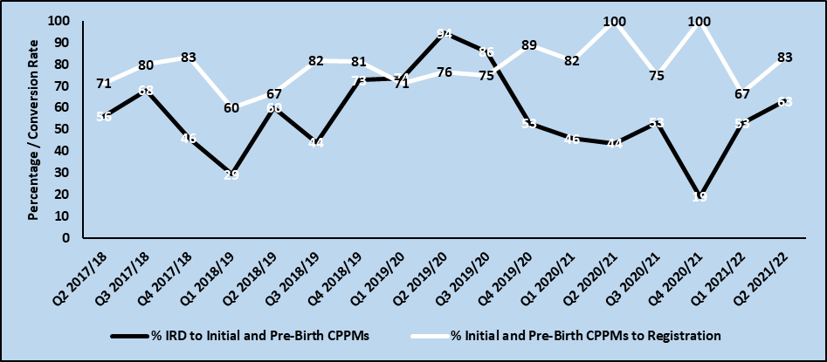

Scrutiny questions to support analysis of the data:
- What are the conversion rates telling us – e.g. about thresholds?
- If CP Investigation is a distinct local process, what are the conversion rates for?
  - IRD to CP Investigation
  - CP Investigation to CP Planning Meeting
- What reasons/factors led to children not progressing to further child protection processes; and are the needs of these children being met?

CHILD PROTECTION REGISTER

Indicators 7, 9 & 10: Number of Children (including Pre-Birth) on the Child Protection Register, New Registrations, and De-Registrations
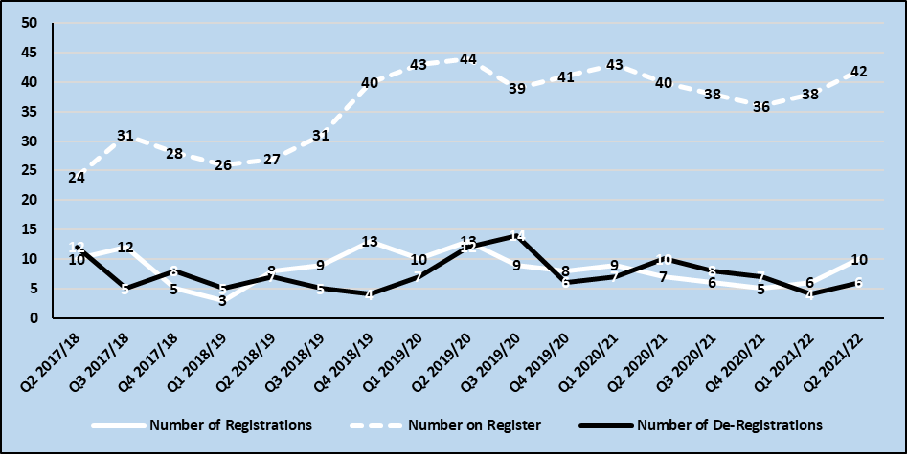

Scrutiny questions to support analysis of the data:
- How many transfer in registrations have been received – and what are the characteristics of those children (including the originating local authority area / country)?
- How many temporary registrations/notifications have been received?
- What factors have led to the number of children on the Child Protection Register increasing and/or decreasing (e.g. number of registrations versus length of time on register versus number of de-registrations)?
- How long have children been on the Register (e.g. how many/what proportion have been registered for more than 1 year)?
- How long had children been registered at time of de-registration (e.g. less than 6 months; 7-12 months; 13-24 months; and 2 years plus)?
- What were the reasons for deregistration? What percentage of children had ‘improved home situation’ so keeping children and families together?

Indicator 8: Number of Re-Registrations within 3, 6, 12 and 24 months of de-registration
 | Q1 20/21 | Q2 20/21 | Q3 20/21 | Q4 20/21 | Q1 21/22 | Q2 21/22 | Q3 21/22 | Q4 21/22
3 month
6 months
12 months
24 months

Scrutiny questions to support analysis of the data:
- What has changed in these children’s lives since they were de-registered?
- What supports have been provided in the post de-registration period?
- How many times have the children previously been registered (e.g. multiple occasions)?

CHARACTERISTICS OF OUR VULNERABLE CHILDREN AND YOUNG PEOPLE

Indicator 11A: Age of Children and Young People at Registration

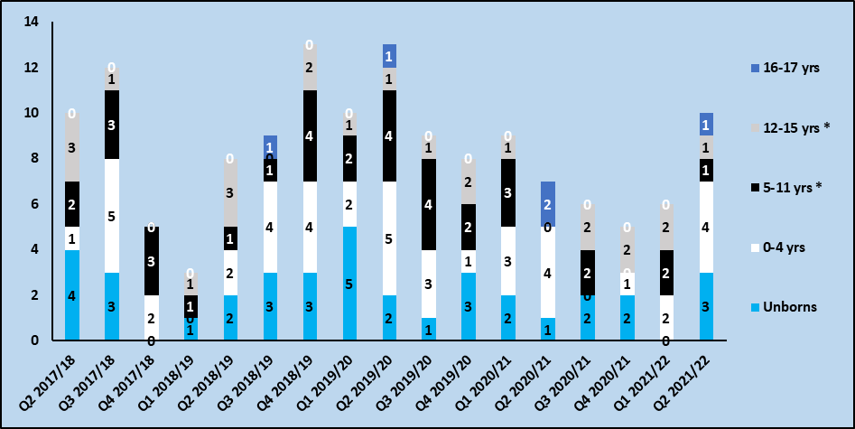

Scrutiny questions to support analysis of the data:
- What factors explain any change(s) in the age profile? For example, improved awareness and identification of concerns among age-specific workforces; impact of a recent Learning Review; impact of wider social, economic or service-related factors; etc.?
- For pre-birth registration, how does the number of registrations compare with annual maternity health indicators, e.g. number of babies diagnosed with neonatal abstinence syndrome or foetal alcohol syndrome?
- Does local service provision reflect the age profile (and development stage needs) of newly registered children?

Indicator 11B: Long-term physical or mental health conditions or illnesses of children at registration
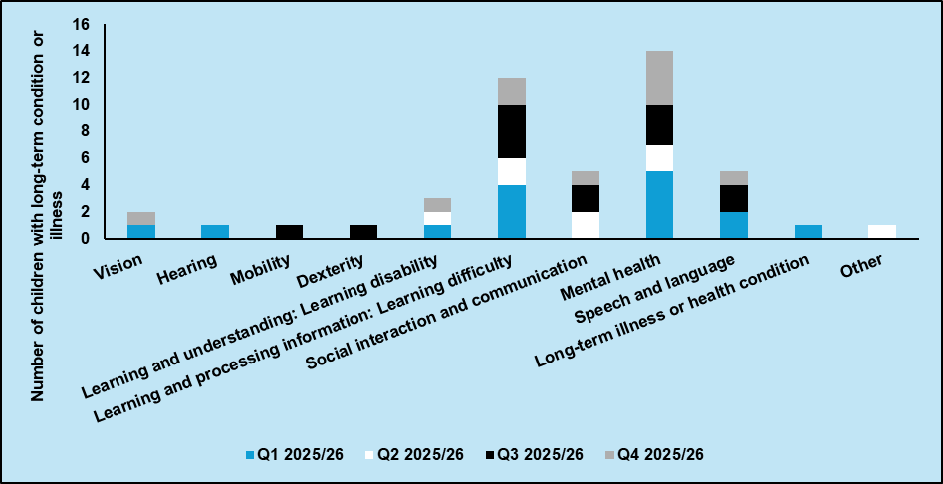
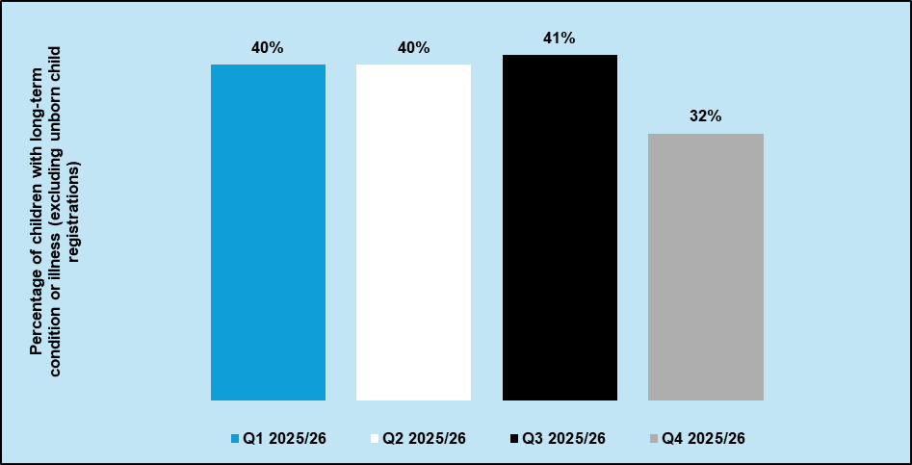
Scrutiny questions to support analysis of the data:
- What factors explain any change(s) in the physical or mental health conditions or illnesses profile? For example, improved awareness and identification of conditions and illnesses; impact of wider social, economic or service-related factors; etc.?
- What is the balance between children with medically diagnosed conditions or illnesses, and children with conditions or illnesses that are present but without a current diagnosis and/or an assessment is pending?
- Does local service provision reflect the physical or mental health conditions or illnesses profile of newly registered children?

SCRUTINY QUESTIONS FOR INDICATOR 12 (SEE NEXT PAGE)

Scrutiny questions to support analysis of the data:
- How does the concerns profile at registration compare with the concerns profile at earlier stages of the child protection process (e.g. IRD)?
- What factors explain any change(s) in the concerns profile? For example, genuine emergent concerns, training on specific concern(s) leading to increased identification, changes in how concerns are recorded, or impact of a recent Learning Review?
- Does local service provision reflect the most prevalent concerns identified?
- How do the concerns interact with wider Public Protection (e.g. Adult Support and Protection) concerns?
- To what extent are parental concerns (e.g. domestic abuse; parental drug or alcohol use) shared with other Public Protection groupings to inform wider service planning?

Indicator 12: Concerns recorded for children placed on the Child Protection Register at a Pre-birth or Initial Child Protection Planning Meeting (% of new registrations in quarter)
 | YEAR 2019/20 LOCAL | YEAR 2019/20 SCOT-LAND | Q1 20/21 | Q2 20/21 | Q3 20/21 | Q4 20/21 | YEAR 2020/21 LOCAL | YEAR 2020/21 SCOT-LAND | Q1 21/22 | Q2 21/22 | Q3 21/22 | Q4 21/22
VULNERABILITY FACTORS
Services finding it hard to engage | % | 22% | % | % | % | % | % | 22% | % | % | % | %
Child affected by Parent/Carer Learning Difficulty or Learning Disability | % | NEW | % | % | % | % | % | NEW | % | % | % | %
Child affected by Parent/Carer Mental Ill-Health | % | 37% | % | % | % | % | % | 44% | % | % | % | %
Child experiencing Mental Health Problems | % | NEW | % | % | % | % | % | NEW | % | % | % | %
Domestic Abuse | % | 44% | % | % | % | % | % | 47% | % | % | % | %
Parental Alcohol Use | % | 13% | % | % | % | % | % | 11% | % | % | % | %
Parental Drug Use | % | 19% | % | % | % | % | % | 19% | % | % | % | %
Child displaying Harmful Sexual Behaviour | % | NEW | % | % | % | % | % | NEW | % | % | % | %
Online Safety | % | NEW | % | % | % | % | % | NEW | % | % | % | %
IMPACTS ON / ABUSE OF THE CHILD
Physical Abuse | % | 21% | % | % | % | % | % | 24% | % | % | % | %
Emotional Abuse | % | 38% | % | % | % | % | % | 38% | % | % | % | %
Sexual Abuse | % | 7% | % | % | % | % | % | 7% | % | % | % | %
Criminal Exploitation | % | NA | % | % | % | % | % | NA | % | % | % | %
Child Trafficking | % | NA | % | % | % | % | % | NA | % | % | % | %
Neglect | % | 39% | % | % | % | % | % | 42% | % | % | % | %
Female Genital Mutilation | % | NA | % | % | % | % | % | NA | % | % | % | %
Honour-based abuse and Forced Marriage | % | NEW | % | % | % | % | % | NEW | % | % | % | %
Child Sexual Exploitation | % | 2% | % | % | % | % | % | 4% | % | % | % | %
Internet-enabled Sexual Offending | % | NEW | % | % | % | % | % | NEW | % | % | % | %
Underage Sex | % | NEW | % | % | % | % | % | NEW | % | % | % | %
Other Concern(s) | % | 17% | % | % | % | % | % | 19% | % | % | % | %
TOTAL NUMBER OF REGISTRATIONS |  | 3,967 |  |  |  |  |  | 3,454

CHILDREN INVOLVED IN RELATED PROCESSES

Indicators 13A, 13B & 14: Number of Children subject to Age of Criminal Responsibility IRDs and Investigative Interviews, and CARM Proceedings
 | Aug-Oct | Nov-Jan | Feb-Apr | May-Jul | Aug-Oct | Nov-Jan | Feb-Apr | May-Jul
 | Q1 20/21 | Q2 20/21 | Q3 20/21 | Q4 20/21 | Q1 21/22 | Q2 21/22 | Q3 21/22 | Q4 21/22
Number of children subject to ACR IRDs starting | Not available until later in 2022
Number of ACR Investigative Interviews | Not available until later in 2022
Number of children referred to CARM or equivalent proceedings

Scrutiny questions to support analysis of the data:
- Where CARM quarterly numbers are high, suggest consideration of other CARM measures set out in Framework for Risk Assessment Management and Evaluation with children aged 12-17

Indicators 15A & 15B: Number of Children Referred to the Children’s Reporter
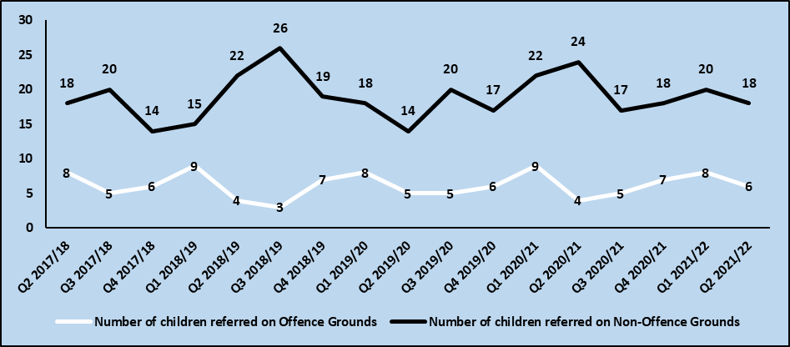

Indicator 16: Child Protection Orders Granted
 | Q1 20/21 | Q2 20/21 | Q3 20/21 | Q4 20/21 | Q1 21/22 | Q2 21/22 | Q3 21/22 | Q4 21/22
Number of children with CPO granted

Scrutiny questions to support analysis of the data:
- What are the sources of the referrals to the Reporter?
- How many referrals to the Reporter have come from Child Protection Planning Meeting or other multi-agency child protection and risk management processes?
- How many and/or what proportion of Child Protection Orders were applied for but not granted? What were the reasons for them not being granted?

CHILD PROTECTION PROCESS TIMESCALES

Indicators 17–20: Timescales in the National Guidance for Child Protection in Scotland (Percentage within Timescale)
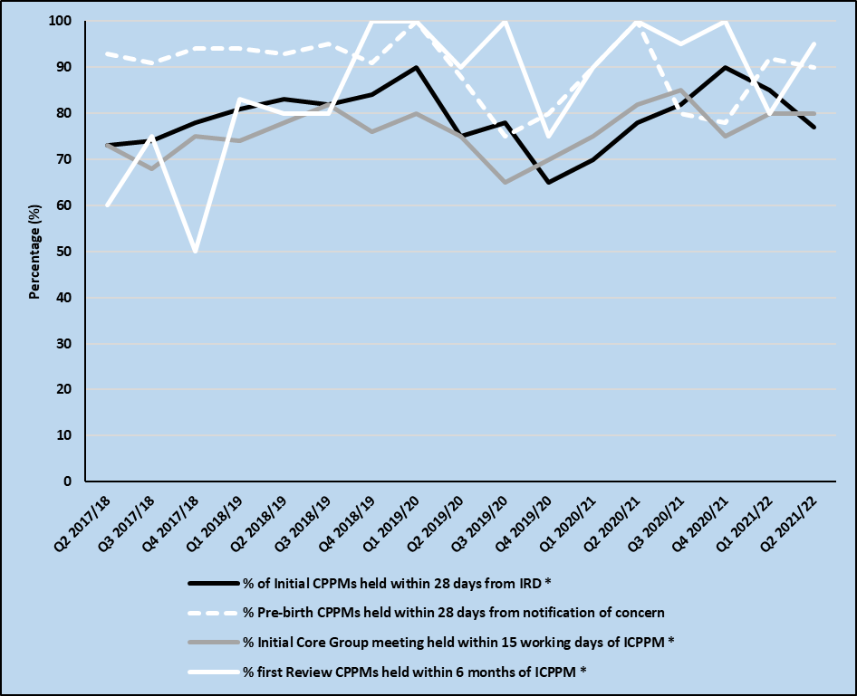

Scrutiny questions to support analysis of the data:
- Where timescales are not being met, what are the reasons for this? For example, are they due to delays that are in the child’s interests, or due to the availability of resources?

Indicator 21: Reporter Decisions within 50 working days of Referral Receipt (%)
 | Q1 20/21 | Q2 20/21 | Q3 20/21 | Q4 20/21 | Q1 21/22 | Q2 21/22 | Q3 21/22 | Q4 21/22
50 days Reporter Decision

Scrutiny questions to support analysis of the data:
- How do timescales locally compare with the national target of 78% of decisions made by the Reporter about a referral within 50 working days of receipt?
- Where the target is not being met, what are the reasons for this? For example, are they due to delays that are in the child’s interests, or due to the availability of resources?

PARENTAL OR CARER ATTENDANCE AT INITIAL CHILD PROTECTION PLANNING MEETINGS AND INITIAL CORE GROUP MEETINGS

Indicators 22A & 22B: Percentage of parental / carer attendance at Initial / Pre-Birth CPPMs and Initial Core Group Meetings
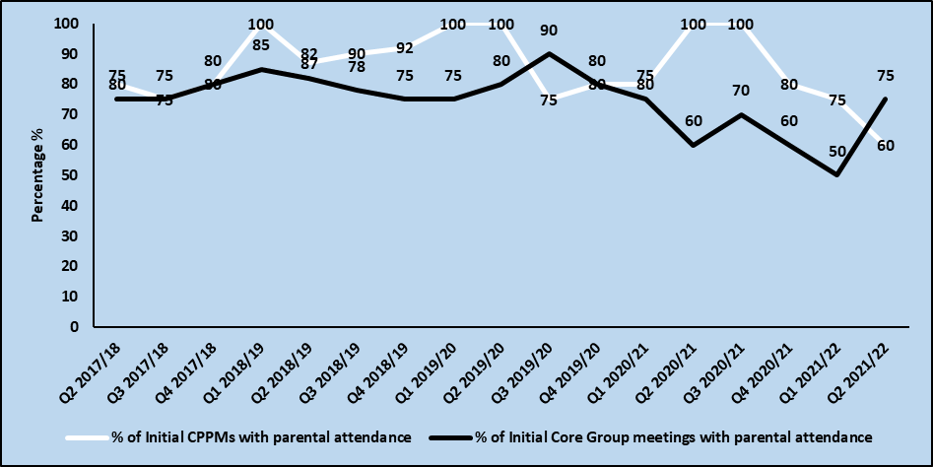

Scrutiny questions to support analysis of the data:
- Where there was no parental/carer attendance, what were the reasons for this?
- Are both parents/carers attending – particularly the parent/carer where the risk lies and/or who need to change their behaviour?
- To what extent are parents/carers active contributors to the meetings – i.e. what is the quality of their participation?
- How are services engaging non-attending parents/carers with child protection planning?
- What was the level of professional attendance and participation at meetings?

OUTCOMES
The following indicators can also be considered as proxy outcomes in that they may indicate important changes in the safety of children, and the level of parental engagement and participation in the child’s planning process.

- Indicator 8: Number of child protection re-registrations (within 3, 6, 12 and 24 months of deregistration
- Indicator 10: Number of children de-registered from the child protection register. Including the Scrutiny Question of: What were the reasons for deregistration? What percentage of children had ‘improved home situation’ so keeping children and families together?
- Indicator 22A: Percentage of parental / carer attendance at Initial Child Protection Planning Meetings
- Indicator 22B: Percentage of parental / carer attendance at Initial Core Group Meetings

The recording of children’s CHI and Scottish Candidate Number(s) (as appropriate to the age of the child) in the Social Work IT system is also encouraged to support data linkage / outcomes work with children’s health and education data

ANNUAL NATIONAL TO LOCAL BENCHMARKS, AUGUST 2020 – JULY 2021

 | Local | Scotland
Early Stage Child Protection Activity
1: Rate of children subject to Police Scotland-recorded child protection concern reports per 1,000 children aged 0-17 |  | NA
2A: Rate of children subject to IRDs starting per 1,000 children aged 0-17 |  | NA
3: Rate of children subject to a JII per 1,000 children aged 0-17 |  | NA
4: Rate of children subject to CPME per 1,000 children aged 0-17 |  | NA
Child Protection Planning Meetings
5A: Rate of children subject to Initial/Pre-Birth CPPMs per 1,000 children aged 0-17 |  | 4.4
Conversion Rates
6A: Conversion Rate of Children from IRD to Initial/Pre-Birth CPPM |  | NA
6B: Conversion Rate of Children from Initial/Pre-Birth CPPM to Registration |  | 76%
Child Protection Register
7: Rate of Registrations per 1,000 children aged 0-17 |  | 3.4
8: Rate of Re-Registrations (within 24 months) per 1,000 children aged 0-17 |  | 0.3
9: Rate of Children on the Register per 1,000 children aged 0-17 |  | 2.0
10: Rate of De-Registrations per 1,000 children aged 0-17 |  | 3.9
Characteristics of Our Vulnerable Children and Young People
11: % of registrations by age of child:  - Unborn children  - 0-4 years old  - 5-11 years old  - 12-15 years old  - 16-17 years old | - %  - %  - %  - %  - % | - 5%  - 47%  - 35%  - 12%  - 1%
12: % of registrations by concerns | See Report Table
Police Scotland
13A: Rate of Children subject to ACR IRDs starting |  | NA
13B: Rate of Children subject to ACR Investigative Interviews |  | NA
14: Rate of Children subject to CARM processes |  | NA
Children’s Hearing System
15A: Rate referred on Offence grounds per 1,000 children aged 0-17 |  | 2.1
15B: Rate referred on Non-Offence grounds per 1,000 children aged 0-17 |  | 7.8
16: Rate of Child Protection Orders granted per 1,000 children aged 0-17 |  | 0.6
Assessing Local Response and Child Protection Processes
17: % of Initial CPPMs held no later than 28 calendar days from IRD |  | NA
18: % of Pre-Birth CPPMs taking place no later than at 28 weeks pregnancy or, in late notification of pregnancy asap, and in any case within 28 calendar days |  | NA
19: % of Initial Core Group meetings held within 15 working days of Initial CPPM |  | NA
20: % of First Review CPPMs held within 6 months of the Initial CPPM |  | NA
21: % of Reporter's decisions made within 50 working days of referral receipt |  | 70%
22A: % of Initial CPPM with parental attendance |  | NA
22B: % of Initial Core Group meetings with parental attendance |  | NA
Note: ‘Children’ defined as 0-17 year olds; SCRA data refers to April-March 2020-2021 data
LOCAL CHILD PROTECTION PROCESS ADD LOCAL MAP
The diagram below shows the local children protection process, noting that many of the Minimum Dataset indicators report on key stages of this process.

