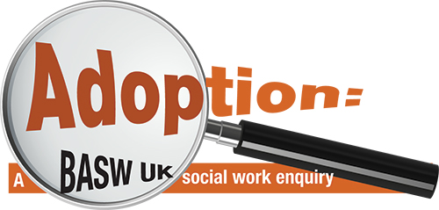

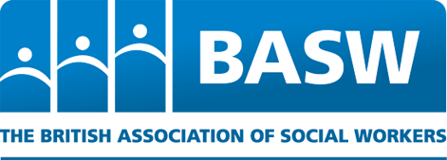

CALL FOR EVIDENCE QUESTIONNAIRE

Prior to completing this form please read the call for evidence briefing paper and consent form.
Please confirm that you have read and attached the consent form □

ABOUT YOU:
Age:
Gender:
Ethnicity:
Which country or region of the UK do you live in? England □ Scotland □ Wales □ N.Ireland □

Please tell us about how you know about adoption: (e.g. are you a birth parent, adopted person, adoptive parent, social worker, lawyer, academic or have other family or professional connections to adoption)

If you are a professional, for how long have you worked in this area?

If a social worker, what is your role and what kind of team do you work in?

If you are replying on behalf of a group or organisation, please provide details of your work and who contributed to the completion of this questionnaire.

QUESTIONS ON THE ROLE OF THE SOCIAL WORKER IN ADOPTION:

We are really keen to hear from you so use this questionnaire in a way that suits you and feel free to tell your story in your own way.

We have listed below a series of headings, as we want to look at the whole process from work with families before children come into care through to contact and support after adoption. Not all of these may be relevant to you so there is no expectation that you will address them all.

1. Work with birth families (children and adults) when there are difficulties and before any recommendation that children should be removed from home, including support and alternatives to children coming into care.

2. Work with birth families (children and adults) during the time a case is in court proceedings (or in Scotland during the time that a case is heard by Children’s Hearings).

3. Decisions at the end of proceedings (or by a children’s hearing) about children going home, being placed with relatives or friends, foster care, adoption or another permanent care option (including where the grounds are contested in court and reasons for overriding the consent of parents in adoption cases).

4. Decisions about the placement of brothers and sisters together or apart during any periods when they are removed from home

5. The assessment and training of adopters.

6. The matching of children with an adoptive family, preparation and moving children to adopters.

7. Decisions about contact with birth parents, brothers and sisters, and other family members after adoption and what happens in practice.

8. Support to all (adopted children and adults, adopters and birth families) involved after the adoption.

Finally could you offer your views in relation to the following broader questions?

- What (if any) are the ethical and human rights dilemmas faced by social workers currently in relation to adoption? e.g. fairness, resources, timescales. Please expand with examples.

- Do you have suggestions for improvements, including changes to the law and policy, in relation to adoption in general and the role of the social worker in particular?

*************

Thank you so much for taking the time to give your views, which will be most helpful to the enquiry.

Please return this form to adoptionenquiry@basw.co.uk

You can also send it by post to:

Professor Brid Featherstone
School of Human and Health Sciences
University of Huddersfield
HD1 3DH

If you wish to talk with someone the following organisations may be of help to you:

Adoption UK is a charity providing support, awareness and understanding for those parenting or supporting children who cannot live with their birth parents. Adoption UK covers all four countries of the UK - www.adoptionuk.org/contact-us

The Open Nest is a charity that was developed by adoptive parents and aims to support adoptive and long term foster care families through a range of respite and support services. It is based in North Yorkshire - www.theopennest.co.uk

PAC-UK provides advice support for anyone who has been affected by adoption or other forms of permanent care. The advice line is staffed by qualified and experienced PAC-UK counselors - www.pac-uk.org

Family Rights Group advises parents and wider family networks whose children are at risk of entering or are in the care system. It covers England and Wales -www.frg.org.uk

Scottish Adoption provide support to adopted children, adopted families and birth families, tailoring services to meet individual need – www.scottishadoption.org

Birthlink provides support including an adoption contact register to all adults affected by adoptions that have taken place in Scotland– www.birthlink.org.

Adopt NI provides support to all those (birth and adoptive families) facing the challenges of adoption and adults whose lives have been impacted in any way by the care system in Northern Ireland – www.adoptni.com

After Adoption provides support and help for people affected by adoption, adopters, birth family and adopted adults in England and Wales – www.afteradoption.org,uk

