How To Document: Timeline Tool

The following tool was created by one of the PACE areas to reduce some of the manual steps in creating a timeline. The following provides some guidance on how to use the tool. Access to Excel will be required to utilise the tool.

There are number of different ways in which to visually display data as a timeline. The example in this document relates to two child siblings and details there placement history. In addition a ‘key events’ chart has been created in conjunction with the placement history to best explain the children’s placement history and any notable key events.

Step 1 – Open File
Open attached Excel file: Timeline Template
The worksheet has three tabs; Placements, Key Events and Print Pictures.

Step 2 – Placement Chart
To create the placement chart you require the placement description and dates of the placements as well as the child/ children’s date of birth. In the last two columns (Days, Years) a formula has been inserted to calculate the length of time in that placement.

Dates from and to for Placement Placement Description i.e. Home,

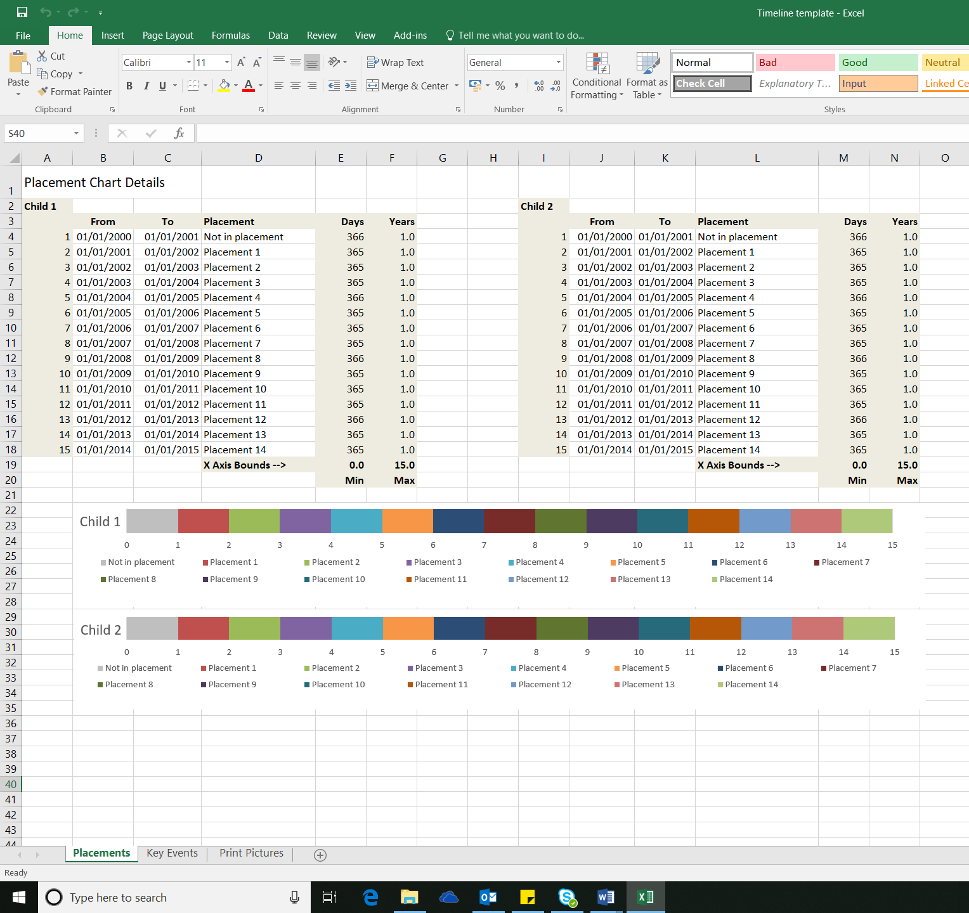

Delete any dates or placements not required. Depending on how many placements you have inserted the Minimum and Maximum will be calculated at the bottom of the Days and Years column.

Next click on the chart, by doing so you should have handles (squares and a boarder around the chart). Then using the shortcut right click on your mouse which will display a list. Click on Select Data.

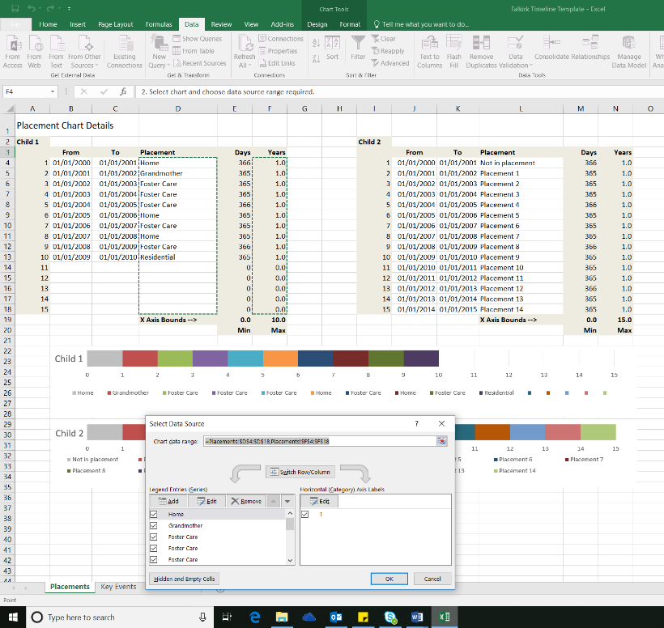
You can then select the data you want to display in your chart.

To do this select your Placements and then using the Control key on the keyboard (Ctrl) select the Years. Then press OK.

You will notice the length of your placement chart has changed.

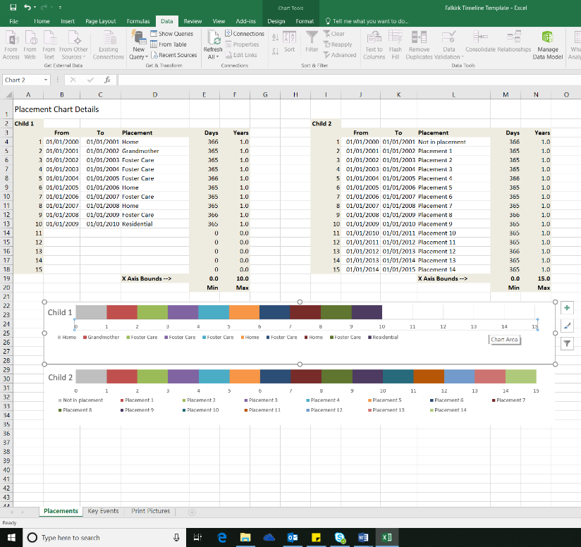
Next select the X Axis. The X Axis is located under the coloured blocks on the chart. It is displaying the child’s age.

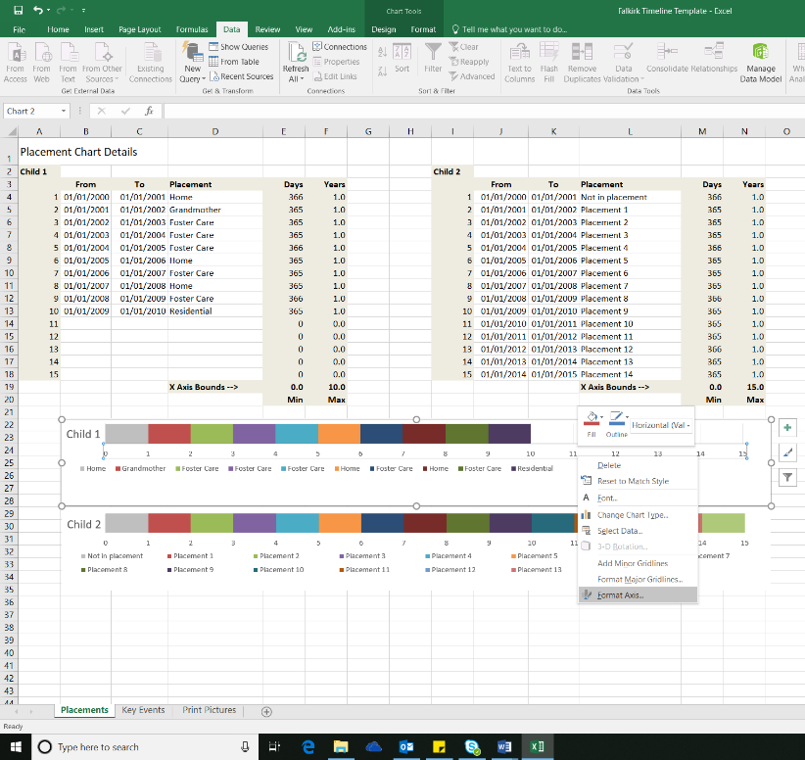
On selecting the X Axis right click on your mouse. A list will be displayed. Select Format Axis. If you are using a new version of Microsoft Office e.g. 2016. A menu bar will appear at the right hand side of the screen.
In the Axis Options set the Maximum to the maximum value on your spreadsheet (located at the bottom of Years). In this example the maximum is 10. Then press enter.

You will notice that your chart has extended to a maximum of 10. The number son the X Axis are the childs age. This visual is displaying the number of placement moves and the age the of the child.

Finally format the individual legend entries e.g. change fill colour or delete duplicates.

To change the colour using your mouse right click on the colour box you want to change then simply select the fill colour. I use an outline of white differentiates between placements. I also colour all the same type of placements the same colour.

To remove extra placement types on the legend simply click on the placement until it has squares on each corner and then press delete on your keyboard.

Step 3 – Key Events Chart

To create a Key Event Chart you require an Event Date and an Event Description. The event description is entered in the Label column. Note; try to keep the description short. The Height column relates to the height of the event lines on the chart, and the Line column relates to the thickness of the line.

Click on the Key Events tab at the bottom of the spreadsheet. Enter your event dates and descriptions.

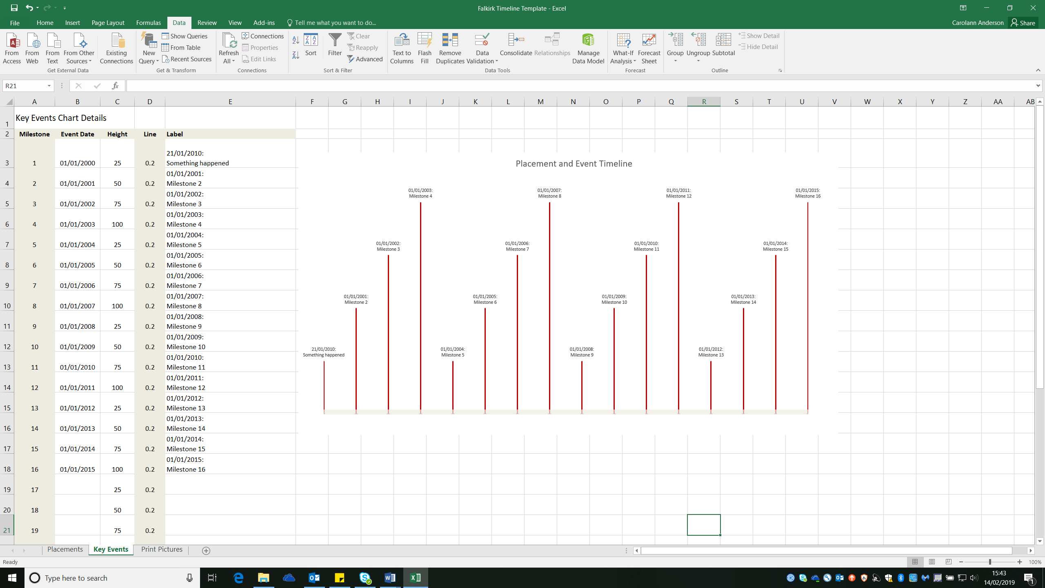

Next select the chart by clicking on it, then using your mouse right click. A list will appear, click on Select Data.

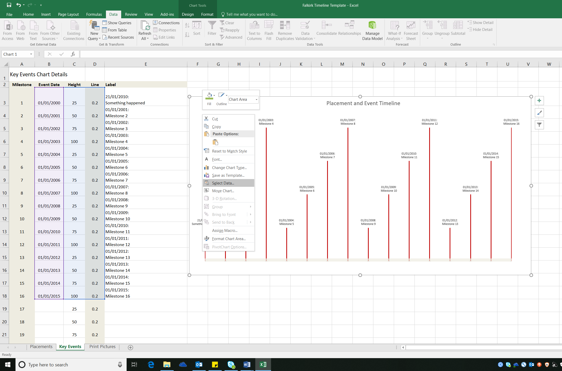
Again using your mouse left click and select the Event Date, Height and Line cells that you have inserted data into. Then press OK. Note you do not need to select the Label.

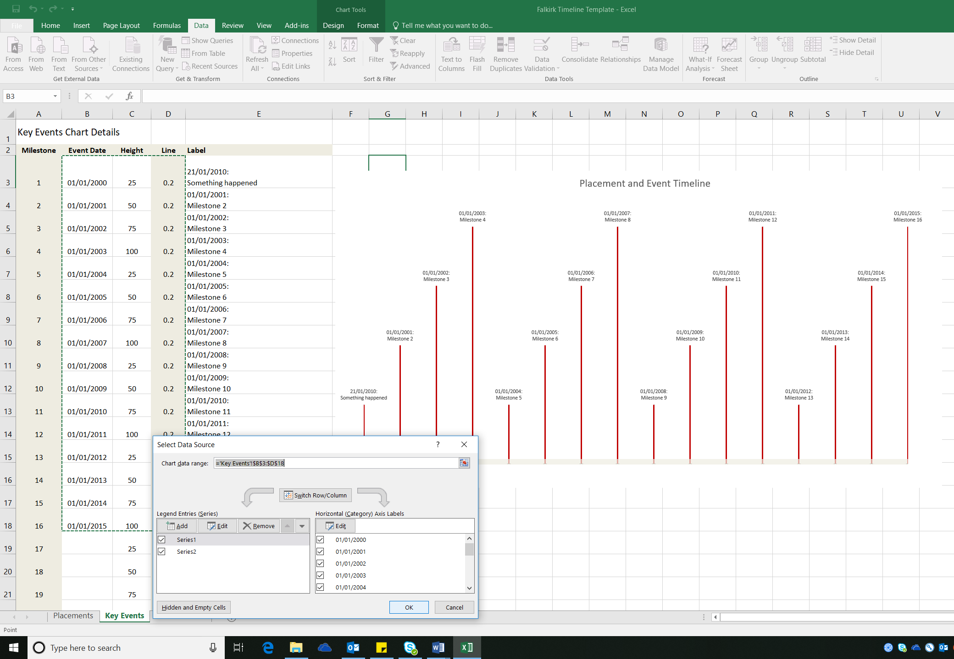

Lastly manually adjust the Height of the labels and label positions to remove overlaps. To adjust the height of labels change the numbers in the Height column associated with that event date/ description. To adjust the position of the labels, using your mouse left click on the label. A box will appear around the label that you can then move.

Step 3 – Print Picture

To create the final visual click on the Placements tab at the bottom of the spreadsheet. Then select (using mouse Left click) the Placement Chart you created. Then copy the chart, you can either right click on the chart which opens a list and then select copy of go to the Home menu at the top of the screen and click on copy. Next click on the Print Pictures tab at the bottom of the spreadsheet and then right click mouse and select paste or again go to Home menu at top of screen and select paste. Following the above instructions do the same with the Key Events Chart. To finish the Key Events Chart is at the top and the Placement Chart is at the bottom. For them to line up you may need to adjust the length of the chart. To do this use your mouse and left click on the chart to select it and then adjust the length of charts as require
